

Edvard Tsymbala Kupchynskyy

Investment Policy Statement with Portfolio Models  
HULT International Business School  
BMFIN1 Portfolio Management  
Professor Paul Ahn

Table of Contents

1. Purpose 3

The Investment Policy Statement: 3

2. Duties and Responsibilities 3

a. The Advisor 3

b. The Client 3

3. Client Profile 4

a. The Portfolio 4

b. Investment Objectives 4

c. Risk Tolerance 5

d. Time Horizon 5

e. Liquidity Needs 6

4. Risk 6

5. Return 7

6. Asset Allocation 7

7. Investment Philosophy 11

a. Overview 11

b. Quantitative Approach 11

c. Investment Selection Criteria 12

d. Taxes 13

8. Performance Evaluation and Reporting 13

9. Rebalancing 14

10. Investment Policy Review 14

11. Advisor Notes 15

12. Appendix & Reference 16

## 1. Purpose

The Investment Policy Statement (“IPS”) is the cornerstone of the investment management process, and it is the foundation upon which our work together will be based. Investment decisions will be made in concert with the guidelines that Edvard Tsymbala Kupchynskyy (the “Advisor”) and Hult International Business (the “Client”) agree upon and outline in this document. The Investment Policy Statement is a channel of communication between the Advisor and the Client, which allows to clarify important issues and concerns of both parties.

#### The Investment Policy Statement:

• Establishes the criteria for matching the Client’s objectives to an appropriate

investment plan.

• Provides a frame of reference to keep the Advisor and Client focused on investment objectives. This focus is especially valuable during periods of market volatility when there may be a temptation to react to short-term factors.

• Establishes the criteria against which progress will be measured.

## 2. Duties and Responsibilities

#### a. The Advisor

Edvard Tsymbala Kupchynskyy, in his capacity as an Investment Adviser, registered with the SEC, will serve as a fiduciary to the Client. He will manage the Portfolio (as outlined in section 3, Client Profile) under this Investment Policy Statement. The Investor carries out the research and keeps track of market trends. Additionally, automated systems are in place to notify the Investor of certain events (such as portfolio drift, movements exceeding set limits, etc.). The Advisor has the following responsibilities:

• Recommending an appropriate asset allocation

• Evaluation & selection of securities within each asset class

• Implementation of the strategy through trading & rebalancing

• Monitoring portfolio performance & drift to make changes as necessary

#### b. The Client

The Client must promptly inform the Advisor of any significant changes in their financial situation or objectives. Any required modifications to the Investment Policy Statement will be made to reflect these changes. The revised Investment Policy Statement will then be discussed with the Client.

## 3. Client Profile

#### a. The Portfolio

This IPS governs the current Management Agreement(s) executed between the Client and Advisor. The accounts listed in the table below (the “Portfolio”) comprise the assets to be managed by the Advisor following this IPS.

Account Value

Hult International Business Savings $1,000,000

Total Investment $1,000,000

#### b. Investment Objectives

A diligent investment process is used to match your objectives with an appropriate investment strategy. The Client desires to obtain the following stated investment objectives by seeking maximum return at an appropriate level of risk.

Growth

It has been determined that the client's Indifference Line meets the Capital Allocation Line of the assets at 89.48%, to meet the correspondent level of risk-return chosen by the client. To meet the client’s fulfillment, we need to allocate the assets as shown in the graph. This will yield the greatest marginal utility per dollar spent. (Index 1) Due to the chosen portfolio strategy, it has been agreed to relocate the earned dividends into the chosen assets to maximize portfolio growth.

#### c. Risk Tolerance

An understanding of your risk tolerance helps define an investment strategy that you will feel confident maintaining through various market conditions. The Risk Tolerance of the client has been determined through a questionnaire to help evaluate the client's profile. (Index 2) The Advisor has discussed the factors that influence your willingness and capacity to assume risk. These factors include your time horizon, financial/tax situation, and investment objectives. Collectively, you and the Advisor have concluded that your risk tolerance score is 64 out of 100, which falls into the category noted below. The risk aversion index is 12.6. Based on this, the client's Maximum Utility for the complete portfolio is 16.29% making the Capital Allocation Line for the expected return of 27.58% meet at 0.9 for the weight of the risky assets in the portfolio. Your Capital Allocation Line meets with your indifference line at these levels. This implies that this is how the assets are best allocated to meet the client’s needs.

Moderately Aggressive

#### d. Time Horizon

In determining your risk tolerance, the Advisor assessed the time horizon for the Portfolio. Generally speaking, the longer the time frame, the more aggressive the portfolio can be. The Advisor has discussed the investment objectives of this portfolio with you, and together you have determined the investment horizon falls into the range noted below.

5 - 10 Years

#### e. Liquidity Needs

The Advisor has discussed your cash needs, and determined if distributions from this portfolio will be necessary to meet those needs. Portfolios with frequent distributions require additional liquidity, which may result in a cash allocation above the target assigned in this agreement.

## 4. Risk

Sufficient assets will be employed to mitigate risks specific to individual securities in the Portfolio. Regular monitoring will be conducted to manage any risks associated with geopolitical events, sectors, or industries within the Portfolio. The Portfolio will be consistently regulated to prevent significant deviation from an optimized portfolio. While it is acknowledged that losses may occur in individual securities, risk, and performance will be evaluated at the overall portfolio level. The Advisor will remain faithful to the investment management styles for which they were appointed and will strive to manage risk, acknowledging that a certain level of risk is essential to achieve the investment objectives.

The conclusion was developed by calculating where the Indifference Line would meet with the Capital Allocation Line to withdraw the best conclusion the most optimal Risky Portfolio allocation with the greatest return. This is shown in the graph below:

## 5. Return

Given the risk tolerance noted above, the Advisor will seek the best possible returns at an appropriate level of risk as described in the Asset Allocation section of this policy statement.

Financial markets fluctuate and there is no guarantee that a certain return will be met, and past performance is not a guarantee of future results. The client wants to allocate the funds to a growth-related account. The expected return in a moderate case scenario of the complete portfolio is 27.58%. The table below represents the expected growth of the portfolio for different scenarios with the allocated investment in the given portfolio. The portfolio assumes the allocation and rebalancing of the dividends earned from each asset, if any, at the end of each fiscal year.

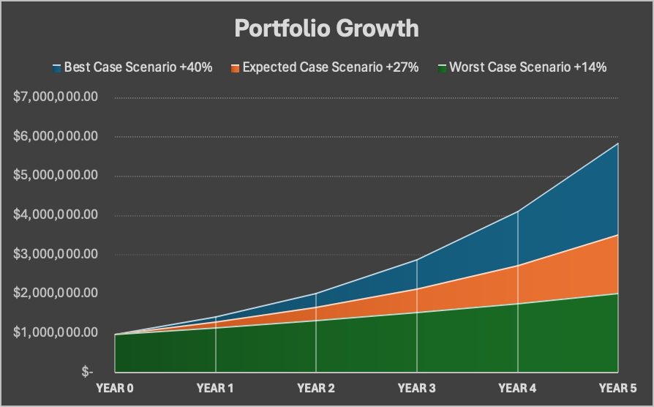



## 6. Asset Allocation

The investor relies on a sound asset allocation strategy. Following is the Strategic Asset Allocation the Advisor recommends for the Portfolio. These targets represent the baseline allocation that the portfolio will maintain under the prevailing market conditions. However, the portfolio may tactically deviate from these targets in response to changes in the risk-to-return profiles of the asset classes.

The portfolio consists of five stocks: D.R. Horton, Inc. (DHI), The TJX Companies, Inc. (TJX), NVR, Inc. (NVR), Chipotle Mexican Grill, Inc. (CMG), and The Home Depot, Inc. (HD). The portfolio is influenced by two indices: the iShares Global Consumer Discretionary ETF (RXI) and the iShares 7-10 Year Treasury Bond ETF (IEF). Here is a brief analysis of each holding:

* D.R. Horton, Inc. (DHI): It is a leading home construction company that has shown strong performance with a positive outlook due to the robust housing market. The company’s net income for the trailing twelve months was $4.73B. The stock has a PE ratio of 11.37, which is relatively low, indicating that the stock could be undervalued.
* The TJX Companies, Inc. (TJX): TJX is a leading off-price retailer. The company has been performing well with a market cap of $113.36B and a revenue of $52.33B. The forward PE is 25.06, indicating expected growth.
* NVR, Inc. (NVR): is a homebuilding and mortgage banking company. It has a market cap of $25.17B and a net income of $1.59B. However, the stock has a high PE ratio of 17.07, which might indicate overvaluation.
* Chipotle Mexican Grill, Inc. (CMG): Chipotle is a leader in the fast-casual dining industry. The company has a market cap of $79.71B and a net income of $1.23B. The stock has a high PE ratio of 65.39, indicating high expectations of future earnings growth.
* The Home Depot, Inc. (HD): Home Depot is a leading home improvement retailer. The company has a market cap of $359.74B and a net income of $15.14B. The stock has a PE ratio of 23.70, indicating a fair valuation with potential future growth.
* iShares 7-10 Year Treasury Bond ETF (IEF): seeks to track the investment results of an index composed of U.S. Treasury bonds with remaining maturities between seven and ten years. The IEF ETF has an expense ratio of 0.15% and a coupon payment of $2.75 par value on a semi-annual basis.

The portfolio allocation is heavily weighted towards the construction and retail sectors, which reflects the current housing market boom and consumer spending trends. The potential reduction in interest rates would greatly benefit these two sectors as it would drive more consumer spending. The high PE ratios for some stocks might indicate overvaluation, which could be a risk factor. However, it is believed that future drops in interest rates and geopolitical changes might affect the stocks positively, further fueling their growth. Some of the assets also pay dividends to improve the growth of the portfolio. The allocation of the bond provides a fixed income in the portfolio which is further reinvested.

Overall Target Asset Allocation:

Moderately Aggressive 14.44

|  |  |  |
| --- | --- | --- |
| Equity  Fixed Income  Risk-Free Asset | 77.18%  12.29%  10.52% | $688,904.67  $272,379.58  $38,715.75 |

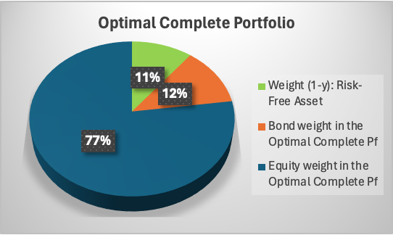

To the extent they can be held due to custodial, retirement plan, or other limitations, securities & products included in the Portfolio may include, but are not limited to the following:

|  |  |
| --- | --- |
| iShares Global Consumer Discretionary ETF (RXI) Index  D.R. Horton (DHI)  The TJX Companies (TJX)  NVR, Inc. (NVR)  Chipotle Mexican Grill (CMG)  The Home Depot (HD)  US Treasury Bill  iShares 7-10 Year Treasury Bond ETF (IEF) | Year 0  $246,401.13  $134,971.23  $134,768.18  $67,374.93  $188,313.39  $105,221.50  $122,949.63 |

To the extent they can be held due to custodial, retirement plan, or other limitations, The portfolio’s investments may include, but are not limited to, the following:

|  |  |
| --- | --- |
| • US Large Cap, Mid Cap, and Small Cap Equity  • Alternative Investments including, but not limited to, Commodities and Real Estate  • US High Yield Bonds  • US Corporate Grade Bonds | • US Floating Rate Bonds  • US Government Securities  • US Convertible Bonds  • Municipal Bonds  • Cash and Cash Equivalents |

The intended distribution represents our strategy for asset allocation as of the date this report was finalized. Any alterations to your investment goals, risk acceptance, investment period, or cash requirements should be relayed to the Advisor. This allows for the evaluation of this distribution to ensure it remains in sync with the objectives.

## 7. Investment Philosophy

#### a. Overview

Consistent with Quantitative, Risk-Managed Investment Strategy, we seek to maximize return for a given level of risk that corresponds with the Client’s risk tolerance. Using an optimized

combination of non-correlated assets to their corresponding index, we strive to attain the highest possible Sharpe Ratio (return per unit of risk) for the Portfolio.

#### b. Quantitative Approach

It includes various performance measures such as the Treynor Measure, Jensen Measure, Information Ratio Measure, and measures of selectivity and diversification effect.

This type of analysis is typically used to make informed investment decisions and manage portfolio risk. It’s a quantitative approach that relies heavily on statistical measures and financial models. The goal is to maximize return for a given level of risk by carefully choosing the proportions of various assets. However, it’s important to note that all these measures are based on historical data and assumptions about the future, and therefore they are not guaranteed to predict future performance accurately.

The Expected Excess Return is the return that is expected from an investment over and above the risk-free rate, which is typically represented by the T-bill rate. The higher the excess return, the better the potential performance of the investment. The Standard Deviation (SD) of Excess Return measures the volatility of the excess return. A higher SD indicates a higher risk associated with the investment. The Sharpe Ratio is a measure of the performance of an investment compared to a risk-free asset, after adjusting for its risk. It is calculated as the average return earned over the risk-free rate per unit of total risk. The Standard Deviation of Residuals measures the firm-specific risk, which is the risk associated with individual stocks that are not due to market-wide movements. On the other hand, the Standard Deviation of the Systematic Component measures the market risk, which is the risk due to market-wide movements. This allows us to narrow down the investments that are going to outperform the market.

Covariance is used as a statistical measure that shows how much two random variables vary together. It is used to calculate the correlation between the returns of different stocks. While Alpha measures the excess return of an investment relative to the return of the benchmark index. Beta measures the sensitivity of the expected excess asset returns to the expected excess market returns. By calculating the beta, we can determine if the stock is going to be volatile compared to the index. The Correlation with the Index measures the degree to which the returns of the stocks move about the market index. This allows us to develop the proportion of each stock in the active portfolio.

#### c. Investment Selection Criteria

When selecting mutual funds, hedge funds, separately managed accounts, and exchange-traded funds (ETFs) for the Portfolio, preference is given to funds that exhibit the following characteristics:

* Total return percentile ranking within peer groups over 5 years.
* The holdings are in the RXI ETF Benchmark Index.
* The holdings have below 1 or negative Beta compared to the Index.
* “Bear Market” return rank at or near the top quartile
* Holdings have a balanced expected excess return.
* Expense ratios in the lowest quartile of the peer group
* Minimum asset size of $100 Million.
* Funds that have a positive Alpha related to the Index.
* Funds must be located in the US.
* Have a low enough P-Value that is below 10% through a Regression analysis of the stock with the Index.
* Funds with Sharpe ratios above their peer means.

When it comes to selecting stocks, a “bottom-up” approach is employed, which focuses on the analysis of individual stocks and their fundamentals. This approach takes into consideration the entire universe of U.S. Exchange-traded common stock. In this process, equities are compared to their respective peer groups based on various financial and operational metrics. The stocks that rank in the top quartile in the largest number of these criteria are then shortlisted. This rigorous selection process helps ensure that only the most promising stocks, as per the established criteria, are considered for investment. (Index 3)

* Return on Equity (ROE) or Return on Assets (ROA)
* Earnings Yield (Earnings Per Share divided by Share Price)
* Free Cash Flow (FCF) divided by Enterprise Value or Market Value
* Current Ratio (Current Assets divided by Current Liabilities)
* Price Earnings Ratio
* Current Stock Price vs Target Price

Once stocks are part of the portfolio, they are tracked and subject to removal from the portfolio at the discretion of the Investor’s judgment in cases where the characteristics making up the original criteria for inclusion have deteriorated.

#### d. Taxes

Research indicates that managing a portfolio with tax efficiency in mind can lead to significant positive alpha generation, especially for assets in taxable accounts. Although general asset allocation primarily influences the Portfolio’s long-term risk and return characteristics, the role of tax efficiency is also integral. Strategies like tax-loss harvesting will be utilized when appropriate. The focus will be on realizing income at rates associated with long-term capital gains and “qualified dividends”. Additionally, fixed-income assets will be evaluated based on their after-tax rate of return.

## 8. Performance Evaluation and Reporting

Portfolio performance evaluation is available through quarterly reports, and ongoing meetings with advisors. We urge you to review these reports and compare them against official custodial records. Our evaluations will measure the portfolio’s performance against the following benchmarks:

Fixed Income: iShares 7-10 Year Treasury Bond ETF (IEF)

Index: iShares Global Consumer Discretionary ETF (RXI)

Risk-Free Asset: 10-Year US Treasury Bill

The portfolio’s benchmark will be weighted according to the model targets chosen in Section 6 of this IPS.

## 9. Rebalancing

The Portfolio will be rebalanced on an annual basis, although frequent rebalancing may take place at the Advisor’s discretion. The capital gains from the distribution of dividends will be relocated accordingly to rebalance the portfolio. This will be done by the following allocation to keep the chosen weights throughout the investment. There might be instances of changing the weights if a decision is made on removing a holding.

## 10. Investment Policy Review

To ensure the ongoing relevance of the guidelines and objectives set out in this investment policy statement, the Client will conduct a yearly evaluation of the policy. By consolidating our mutual understanding into a written format, we strive to minimize the potential for disagreements and misconceptions. As such, we ask for your signature on this Agreement as a confirmation of your concurrence with its contents. It's important to note that this Investment Policy Statement does not serve as a contract in any form. It is merely a synopsis of the investment strategy we have agreed upon for the Portfolio.

## 11. Advisor Notes

This section is dedicated to recognizing the client’s specific situations that need to be addressed during the execution of the investment strategy. These can encompass aspects like the necessity for cash flow from the portfolio, explanation of risk tolerance and strategy, interest in holding securities, preferences related to social and environmental factors, and tax implications associated with substantial holdings acquired at a low cost, among others.

For instance, the client possesses a significant stake in Apple acquired at a minimal cost, leading to considerable tax consequences if sold. We will retain this holding, treating it as an equivalent to Domestic large-cap and aim for diversification aligned with the client’s tax circumstances when suitable.

## 12. Appendix & Reference

References

Yahoo Finance. (2024). *Yahoo Finance - Business Finance, Stock Market, Quotes,*

*News*. Yahoo Finance. <https://finance.yahoo.com/>

‌*iShares 7-10 Year Treasury Bond ETF | IEF*. (n.d.). BlackRock. Retrieved April 8,

2024, from <https://www.ishares.com/us/products/239456/ishares-710-year-treasury-bond-etf#/>

‌*iShares Global Consumer Discretionary ETF | RXI*. (n.d.). BlackRock.

<https://www.ishares.com/us/products/239739/ishares-global-consumer-discretionary-etf>

‌*Penobscot Financial Advisors*. (n.d.). Investment Policy Statement Sample Version. Retrieved April 8, 2024, from <https://mycourses.hult.edu/courses/3444653/files/246395276?wrap=1>

Index 1.

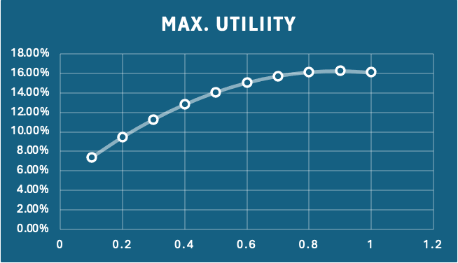

Index 2.

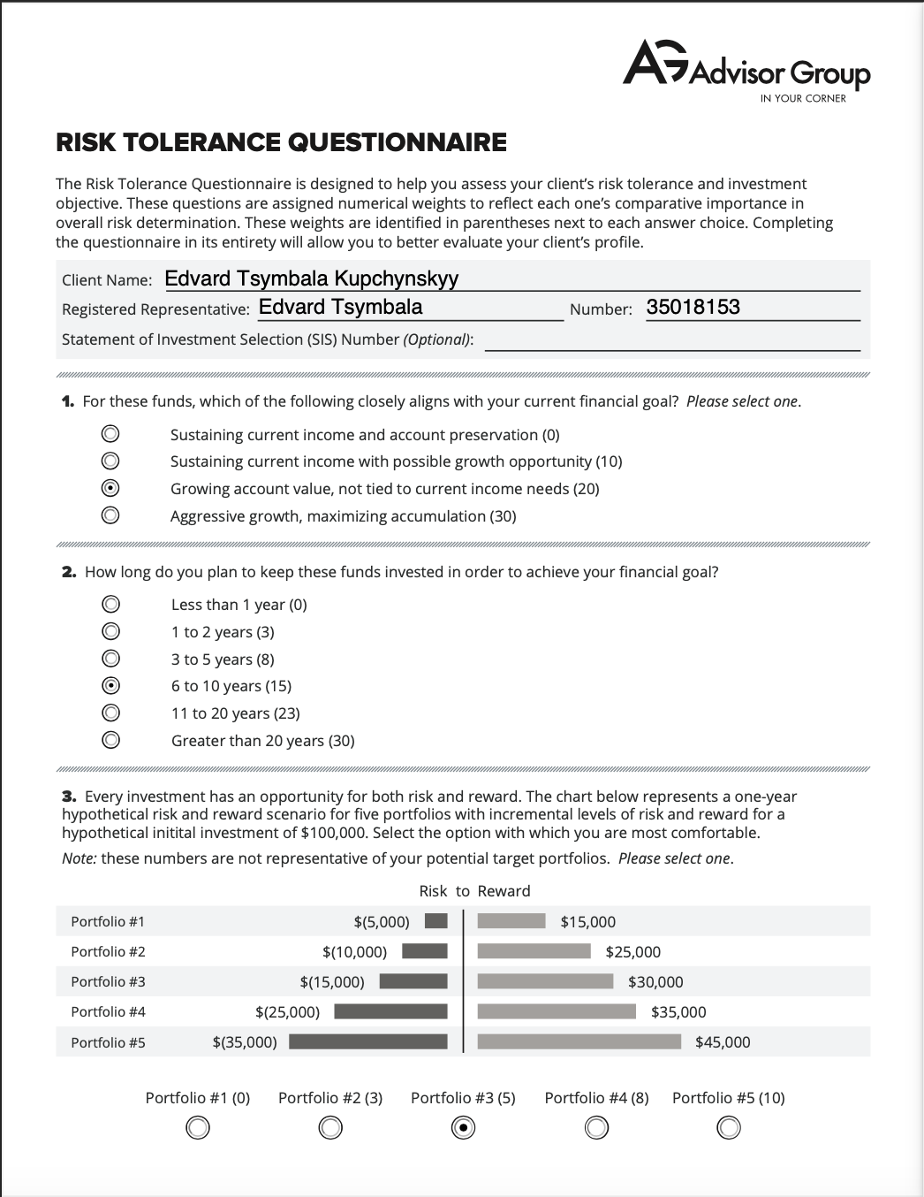

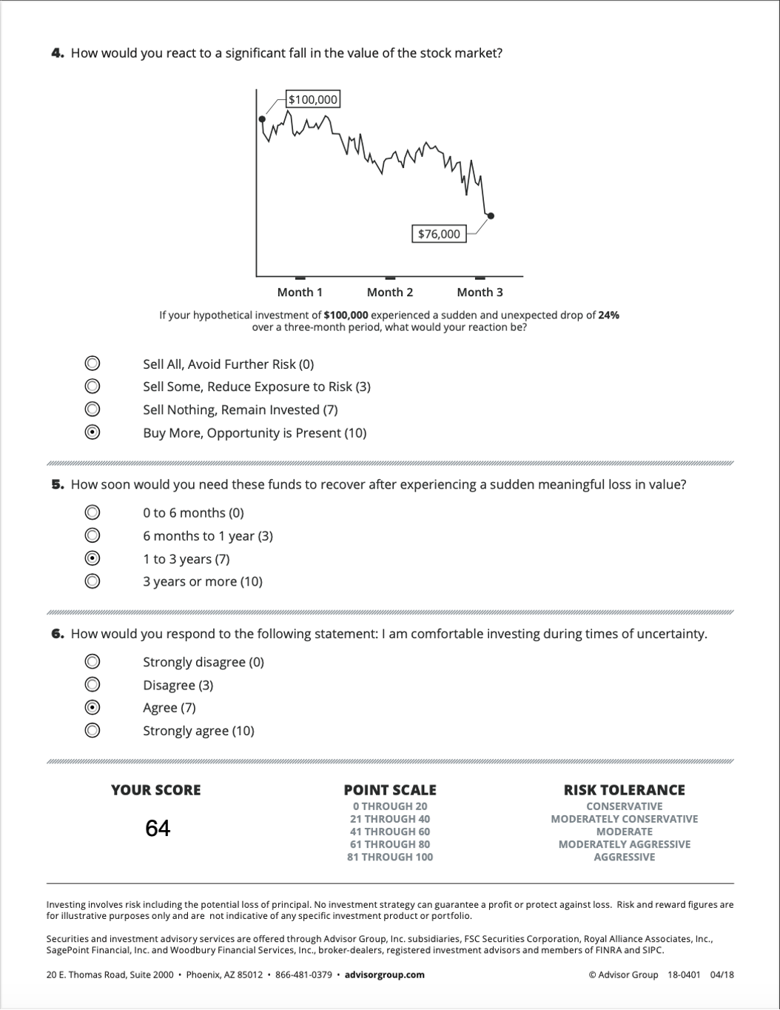

Index 3.